**DAILY ONLINE ACTIVITIES SUMMARY**

|  |  |  |  |  |  |  |  |  |
| --- | --- | --- | --- | --- | --- | --- | --- | --- |
| Date: | 19/06/2020 | | | | | Name: | Jyothi B R | |
| Sem & Sec | IV-A | | | | | USN: | 4AL18CS030 | |
| Online Test Summary | | | | | | | | |
| Subject | | Micro embedded system and micro controller. | | | | | | |
| Max. Marks | | 18 | | Score | | | 20 | |
| Certification Course Summary | | | | | | | | |
| Course | Programming Essentials in Python | | | | | | | |
| Certificate Provider | | | Cisco Virtual Academy | | Duration | | | 3hrs |
| Coding Challenges | | | | | | | | |
| |  |  | | --- | --- | | Problem statement:  Write a C Program to Count total set bits in all numbers from 1 to n. |  | | | | | | | | | |
| Status:Completed | | | | | | | | |
| Uploaded the report in Github | | | | | Yes | | | |
| If yes Repository name | | | | | https://github.com/alvas-education-foundation/jyothi_b_r | | | |
| Uploaded the report in slack | | | | | Yes | | | |

Online Test Details: (Attach the snapshot and briefly write the report for the same)

Certification Course Details: (Attach the snapshot and briefly write the report for the same)

Coding Challenges Details: (Attach the snapshot and briefly write the report for the same)

The online test was from module4. There were 20 questions which contains mcq questions and the duration were 30 minutes. The questions were optimal and easy. The score that I received was 18/20.

**ONLINE TEST DETAILS:**

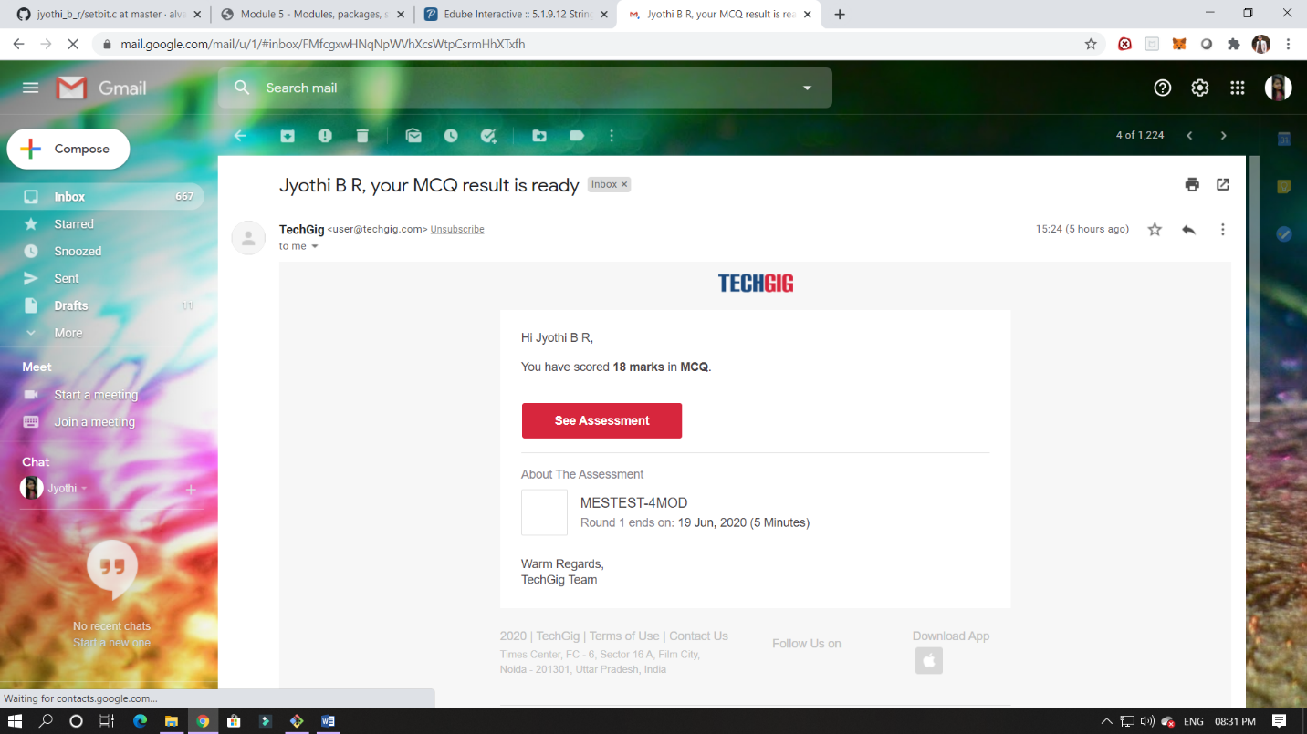

CERTIFICATION COURSE DETAILS:

Programming Essentials in Python :

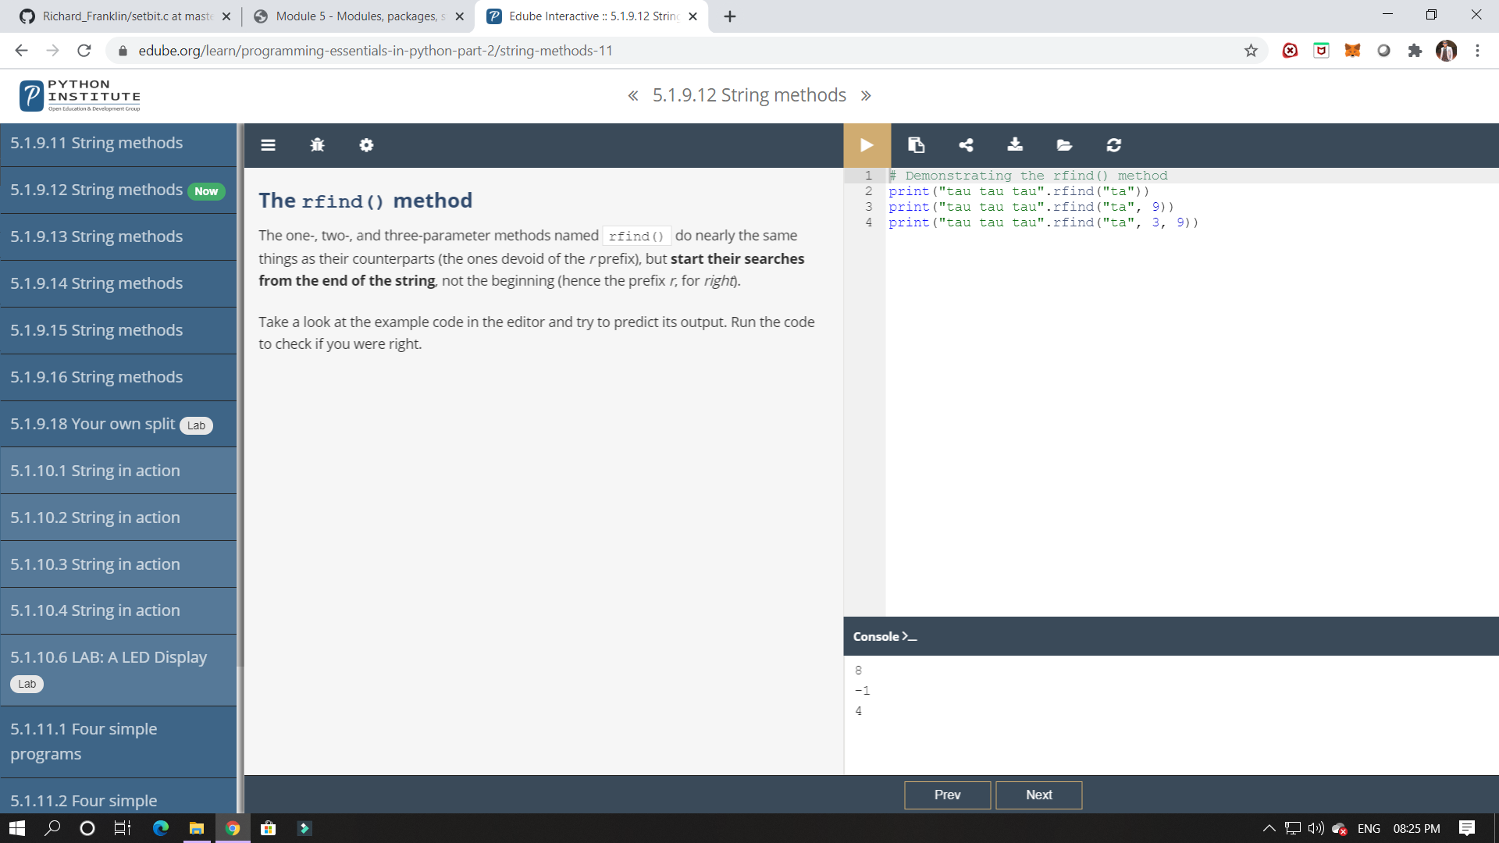

In this module its shows about packages, In this it shows about strings.

In this module I have studied about packages and how it can be implemented in python.

ONLINE CODING:

 Write a C Program to Count total set bits in all numbers from 1 to n

